LAB MANUAL
CSA4301-INTERNET PROGRAMMING
NAME: T S SAI LAHARI
REG NO: 192325137
1. A local library needs a website to streamline operations and enhance user experience. The site will include a catalog for searching and viewing books, user accounts for borrowing and managing books, and an admin dashboard for managing inventory and user data. Essential features include a search function, book details page, user login system, and contact form, The system helps both students and library managers to keep constant track of all the books available in the library. It allows both the admin and the student to search for the desired book. It becomes necessary for colleges to keep a continuous check on the books issued and returned and even calculate fines.
Librarian Admin:
- Login
- Add Book
- Update/Delete Book
- Issue Book for student • Return Book Status
- Make Fine
- Update material ( year, semester wise ) • View material
User
- Login
- Register • Search Book
- My Borrow History Book
- Issue Date, Exp Date
- Check Fine
- Search material
AIM: To design and develop a Library Management System using HTML, CSS, and JavaScript to display books and provide a user-friendly interface for managing library information.
CODE:
<!DOCTYPE html>
<html lang="en">
<head>
<meta charset="UTF-8">
<meta name="viewport" content="width=device-width, initial-scale=1.0">
<title>LibraSpace | College Library</title>
<style>
:root {
--primary: #4f46e5;
--primary-light: #eef2ff;
--bg: #f6f7fb;
--text: #20243a;
--muted: #858ba3;
--border: #e9eaf2;
--white: #ffffff;
--green: #16a36a;
--red: #e05260;
}
* { box-sizing: border-box; margin: 0; padding: 0; }
body {
font-family: Inter, "Segoe UI", Arial, sans-serif;
background: var(--bg);
color: var(--text);
font-size: 14px;
}
button, input, select { font: inherit; }
button { cursor: pointer; }
.app { display: flex; min-height: 100vh; }
.sidebar {
width: 245px; background: var(--white); border-right: 1px solid var(--border);
padding: 26px 17px; display: flex; flex-direction: column; flex-shrink: 0;
}
.brand { display: flex; align-items: center; gap: 11px; padding: 0 10px 32px; }
.brand-icon {
background: var(--primary); color: white; border-radius: 12px;
width: 42px; height: 42px; display: grid; place-items: center; font-size: 23px;
}
.brand h2 { font-size: 20px; letter-spacing: -0.7px; }
.brand p { font-size: 11px; color: var(--muted); margin-top: 4px; }
.nav-label { color: #a2a6b7; font-size: 10px; font-weight: 800; letter-spacing: 1.3px; padding: 16px 12px 10px; }
.nav-btn {
border: 0; background: transparent; width: 100%; padding: 12px;
display: flex; align-items: center; gap: 12px; border-radius: 9px;
color: #6f748c; text-align: left; margin-bottom: 4px; transition: .2s;
}
.nav-btn:hover, .nav-btn.active { background: var(--primary-light); color: var(--primary); }
.nav-btn.active { font-weight: 700; }
.nav-icon { width: 20px; text-align: center; font-size: 17px; }
.sidebar-bottom { margin-top: auto; }
.help-card { background: #f7f7ff; padding: 17px; border-radius: 13px; margin: 22px 0; }
.help-card strong { display: block; margin: 9px 0 5px; }
.help-card p { color: var(--muted); font-size: 12px; line-height: 1.6; }
.help-card button { border: 0; color: var(--primary); background: transparent; margin-top: 10px; font-weight: 700; }
.main { flex: 1; min-width: 0; }
.topbar {
height: 83px; background: white; border-bottom: 1px solid var(--border);
display: flex; justify-content: space-between; align-items: center;
padding: 0 35px; gap: 15px;
}

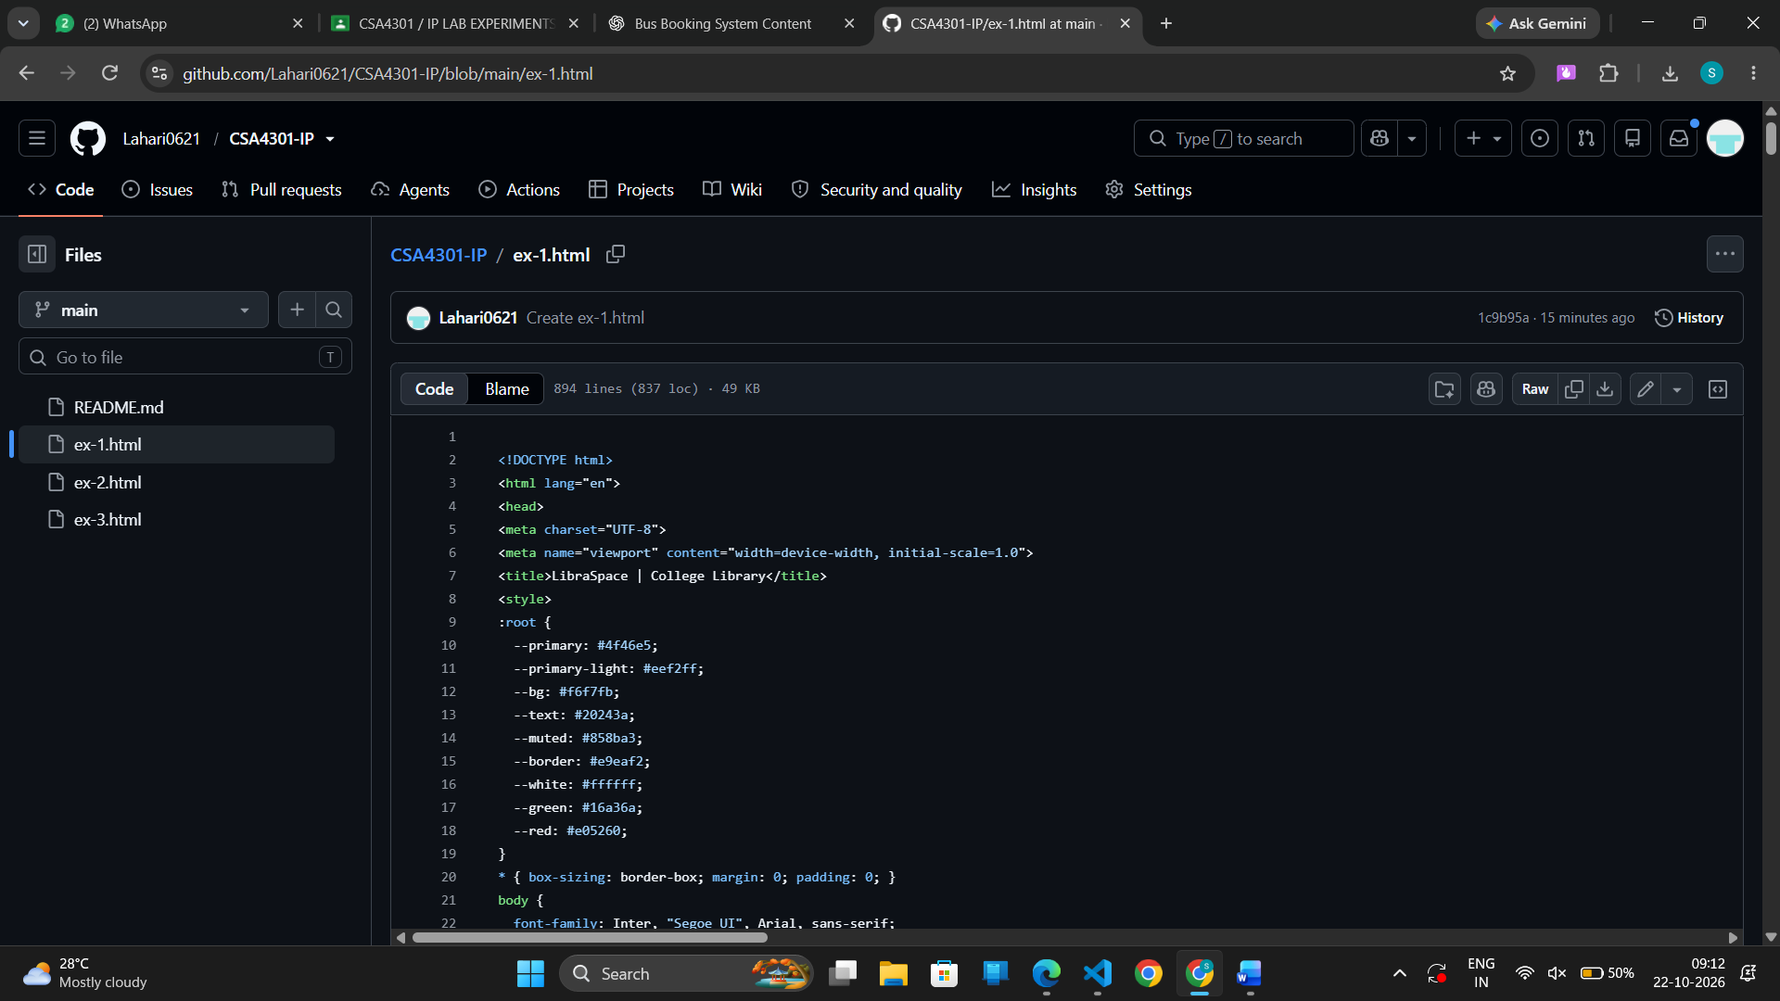
OUTPUT:
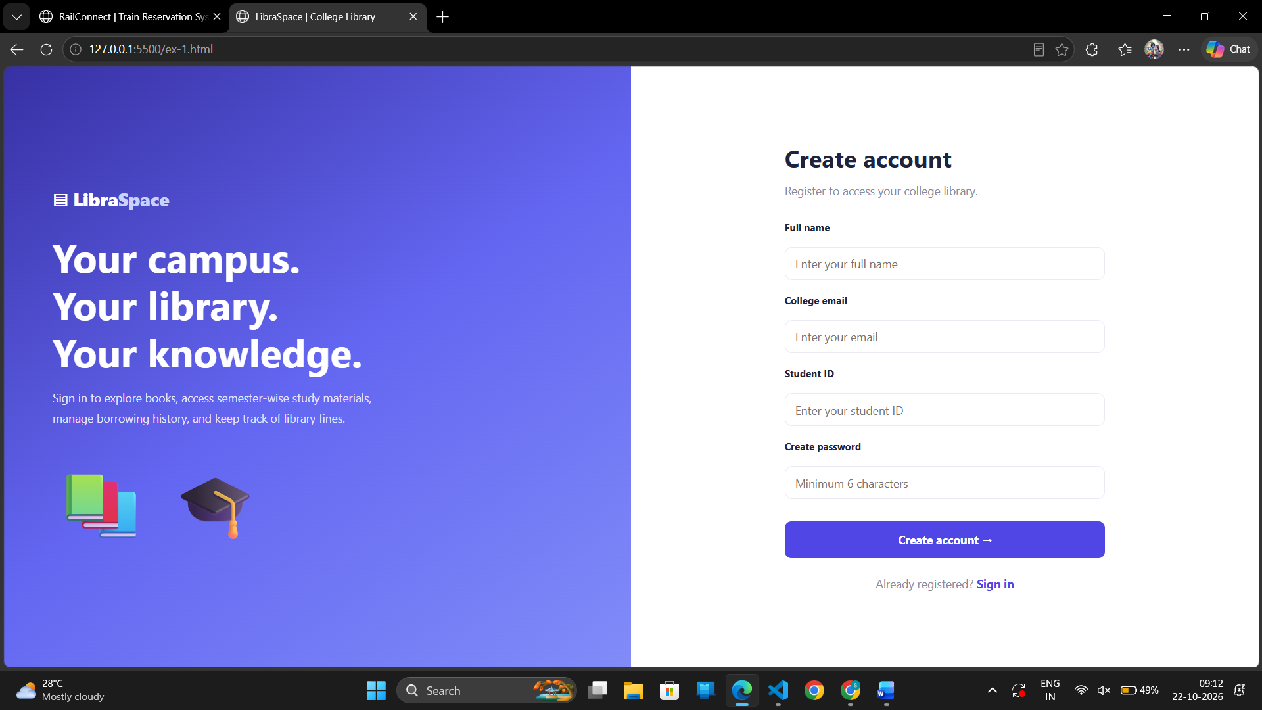
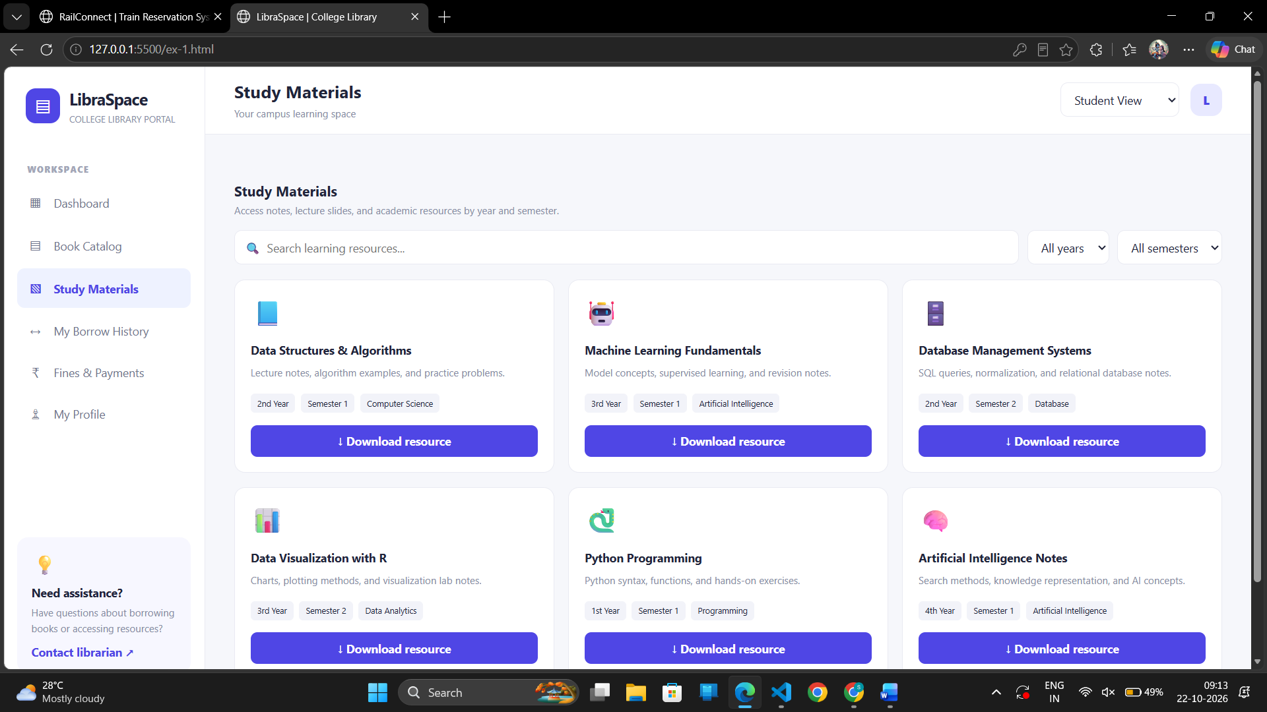
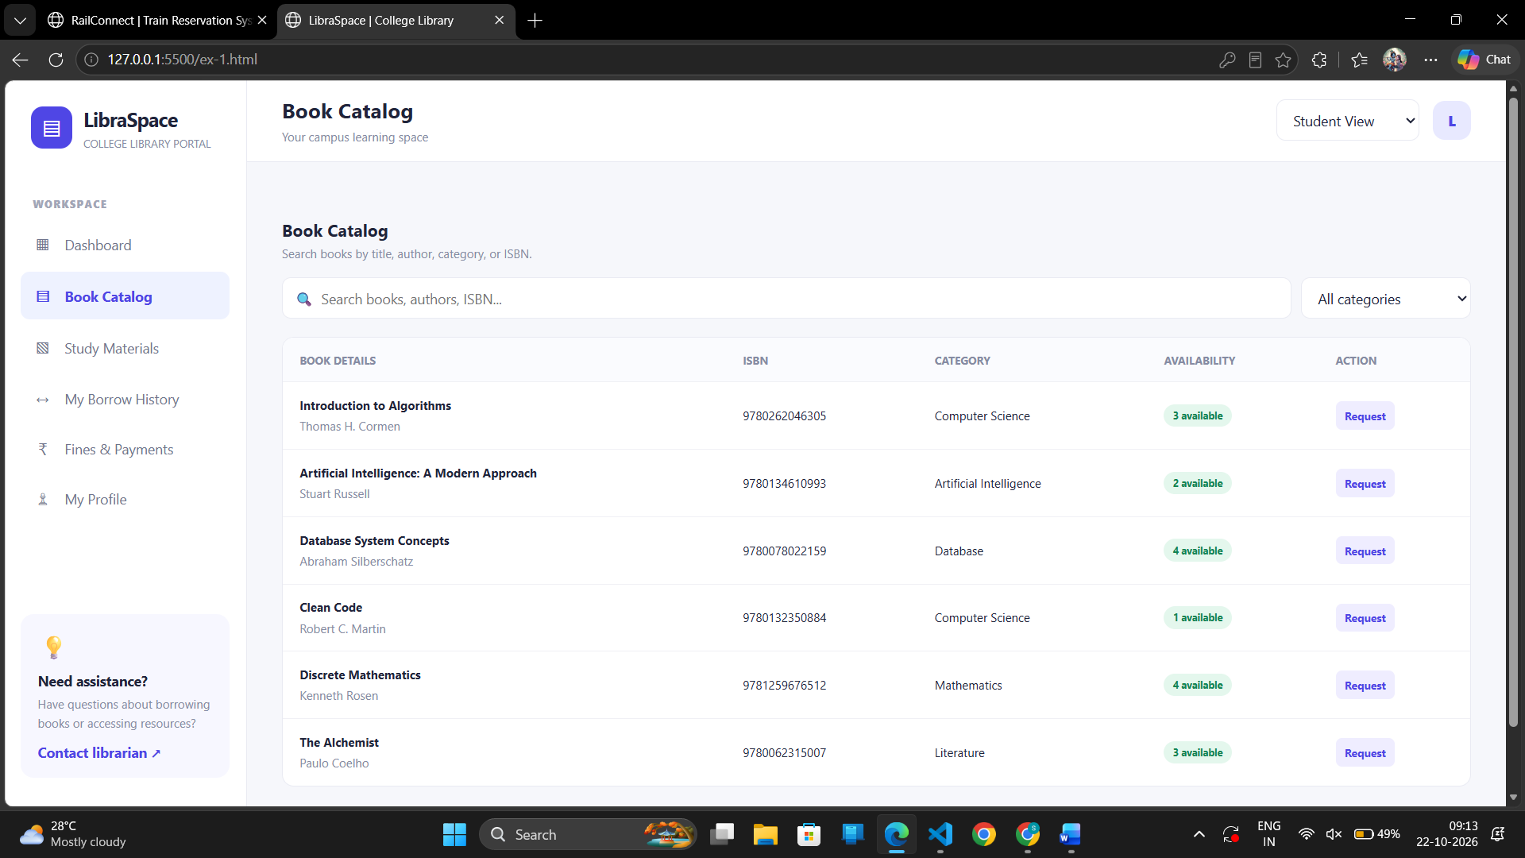
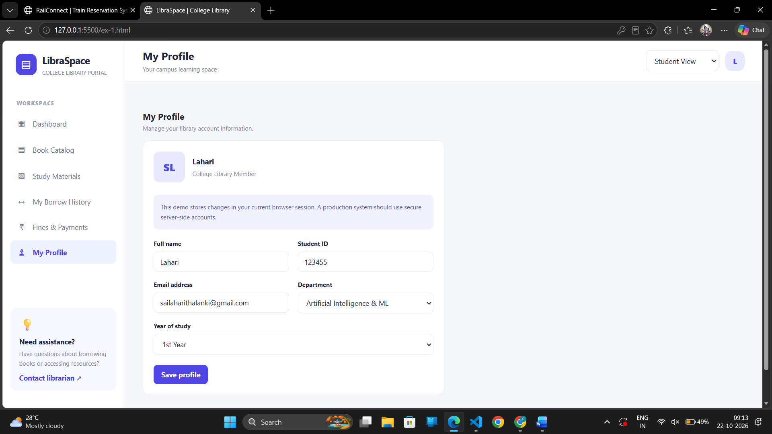

RESULT: Thus, the Library Management System webpage was designed and developed successfully using HTML, CSS, and JavaScript.

2. The online hotel room booking website allows users to search for hotels based on destination, dates, and number of guests, offering detailed listings with room options, prices, amenities, and reviews. Users can create accounts, log in, and manage their bookings through a user-friendly dashboard. The booking process includes checking room availability, filling out a booking form, and completing secure payments via an integrated payment gateway. Post-booking, users receive confirmation emails and can leave reviews and ratings. Admins manage hotel listings, room availability, and user accounts through a dedicated admin panel
The website is fully responsive, ensuring seamless access on all devices.
Functionalities:
Users.
1. Users can register at the hotel and then they can view or modify their profile.
2. Users can book a room on any specific date.
3. Users can view all their booking history at the hotel.
4. Users can change the booking at any time 3 days before the arrival date.
5. Users can cancel the booking at any time 3 days before the arrival date.
6. Users can check the room availability at the hotel before they book a room.
Administrator
7. Administrators can change the quantity and price of all four types of rooms.
8. Administrators can change any specific booking details.
9. Administrators can cancel any specific booking.
10. Administrators can modify the details of static pages including room information, about us
information, contact us information, customer service Q&A details, local travel and shipping
guide, and privacy policy after login.
11. It should also contain a basic room type introduction, contact information, customer service
Q&A, local travel and shipping guide, and a privacy policy
Aim: To design and develop a responsive Hotel Room Booking Website using HTML, CSS, and JavaScript that allows users to search for rooms, check availability, make reservations, manage bookings, and view booking details.
CODE:
<!DOCTYPE html>
<html lang="en">
<head>
<meta charset="UTF-8">
<meta name="viewport" content="width=device-width, initial-scale=1">
<title>StayEase | Hotel Booking</title>
<style>
:root {
--green: #176b59;
--dark: #104b40;
--gold: #e7b76a;
--bg: #f5f7f4;
--text: #24312c;
--muted: #718078;
--border: #e1e8e2;
--red: #bd4141;
}
* { box-sizing: border-box; }
body {
margin: 0;
background: var(--bg);
color: var(--text);
font: 15px Arial, sans-serif;
}
button, input, select, textarea { font: inherit; }
button {
border: 0;
background: var(--green);
color: white;
padding: 11px 16px;
border-radius: 8px;
cursor: pointer;
}
button:hover { background: var(--dark); }
button:disabled { opacity: .5; cursor: not-allowed; }

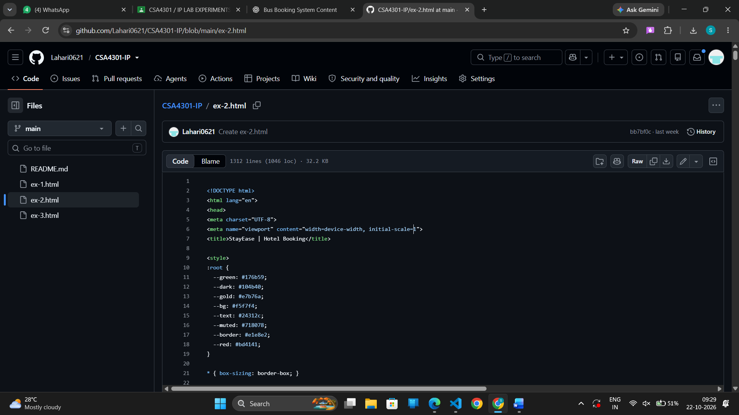
OUTPUT:
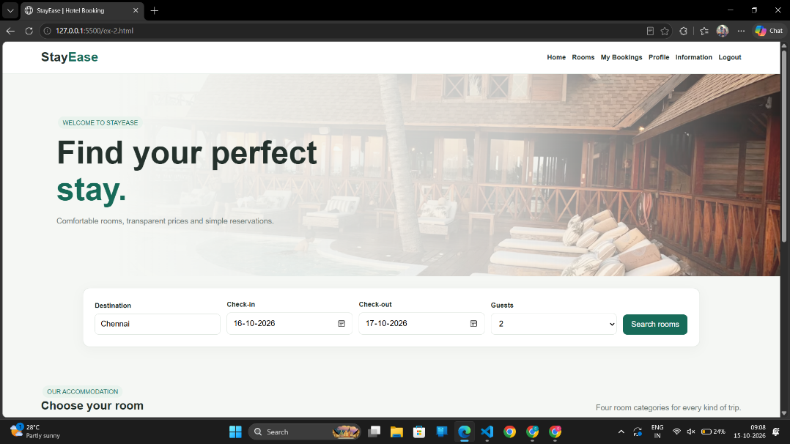
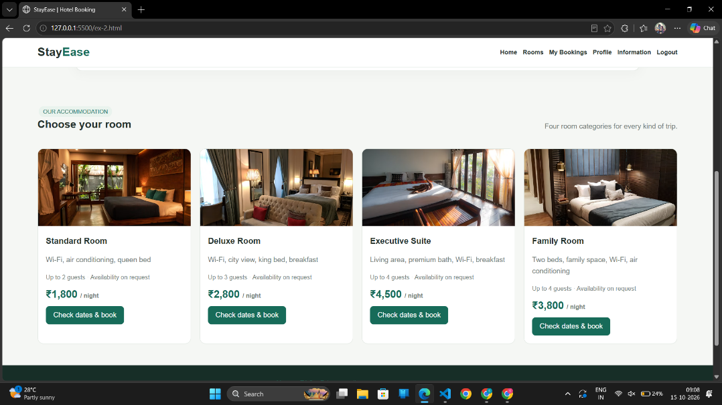
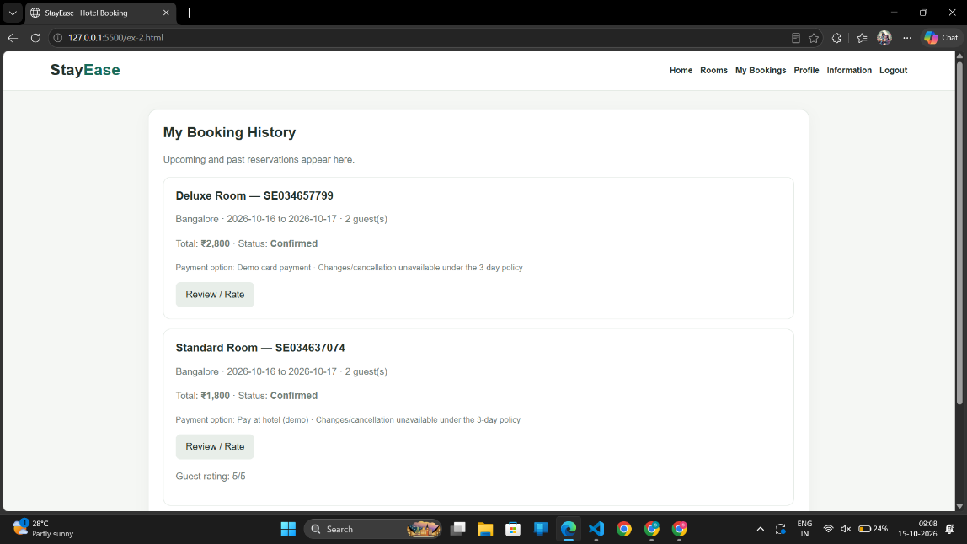
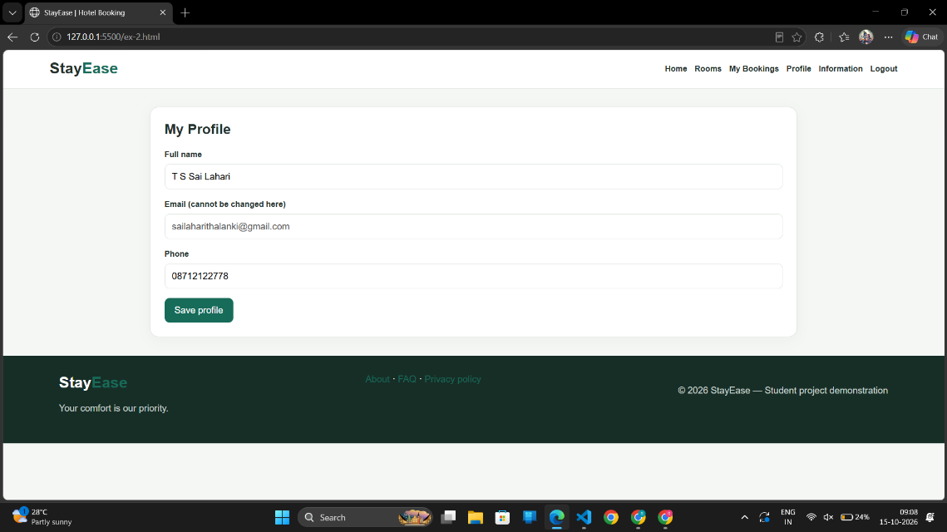
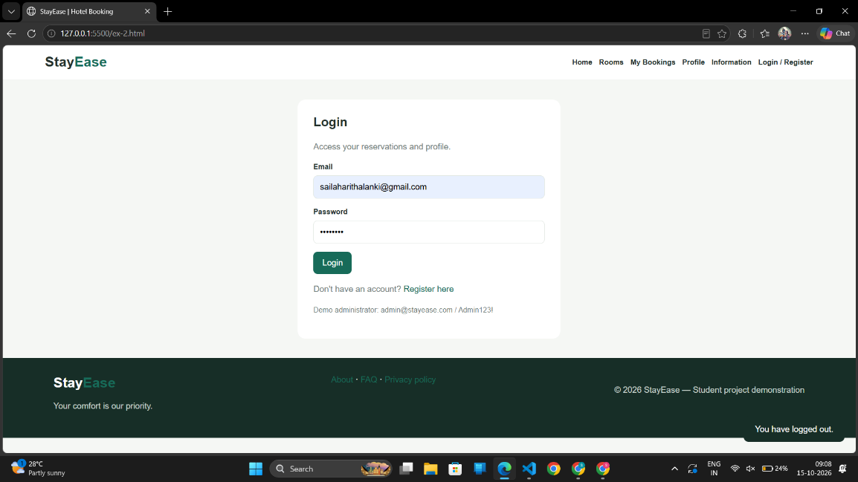

Result: Thus, the Hotel Room Booking Website was developed successfully with room search, availability checking, booking management, and a responsive user interface.
3. The online bus ticket booking system enables users to search for buses by route, date, and time, and view available seats. Users can create an account, log in, and manage their bookings through a personal dashboard. The booking process includes selecting seats, filling out passenger details, and making secure payments via an integrated payment gateway. Admins can manage bus schedules, seat availability, and user accounts through an admin panel. Users receive booking confirmation emails and can view their booking history. The website is mobile-responsive, ensuring easy access on all devices.
Admin
In this system, the admin can maintain all the Bus information and maintain Bus category, comments etc.
In this system, the admin can maintain the registered users, manage news, and the admin can generate reports and manage the whole system.
Login:
Login Module includes various utilities like User Authentication, Change Password and Forgot
Password.
Registration:
This website provides some facilities users can be Registered in this website. user can use this facility so user can make a registration
Book the Ticket:
In this module, the admin can add a new bus category using this module. Bus Category contains like Volvo, Slipper coach, coach etc.
Update Bus Information:
In this module, the admin can add or Update Bus using this module. It contains information about the Bus type, photo, description, Location of the tour, Available Seats in Bus etc.
Cancel the Booking Ticket:
In this Module, the User can cancel the booking Ticket.
Comments:
In this Module, Users can Post Comments on a particular Bus.
Report Generation:
This module is used to generate a report.
Aim: To design and develop a Train Reservation System using HTML, CSS, and JavaScript that enables users to search for trains, select seats, book tickets, check PNR status, cancel reservations, and manage train details through an administrator panel.
CODE:
<!DOCTYPE html>
<html lang="en">
<head>
<meta charset="UTF-8">
<meta name="viewport" content="width=device-width, initial-scale=1.0">
<title>BusGo | Online Bus Ticket Booking</title>
<style>
:root{--navy:#10284b;--blue:#176b87;--orange:#ff6b35;--gold:#ffca5c;--bg:#f4f7fb;--text:#182235;--muted:#718096;--line:#e0e7f0}
*{box-sizing:border-box;margin:0;padding:0}
body{font-family:Arial,Helvetica,sans-serif;background:var(--bg);color:var(--text);line-height:1.5}
header{background:var(--navy);color:white;padding:16px 6%;display:flex;justify-content:space-between;align-items:center;gap:16px;flex-wrap:wrap}
.logo{font-size:25px;font-weight:bold;color:var(--gold)}
nav{display:flex;gap:8px;flex-wrap:wrap}
nav button{background:transparent;color:white;padding:9px 11px}
nav button:hover{background:#ffffff1c}
button{cursor:pointer;border:0;border-radius:7px;padding:11px 15px;font-weight:bold;font-size:14px}
button:disabled{opacity:.55;cursor:not-allowed}
.primary{background:var(--orange);color:white}
.secondary{background:#e7edf6;color:#193456}
.danger{background:#ffe5e5;color:#a52121}

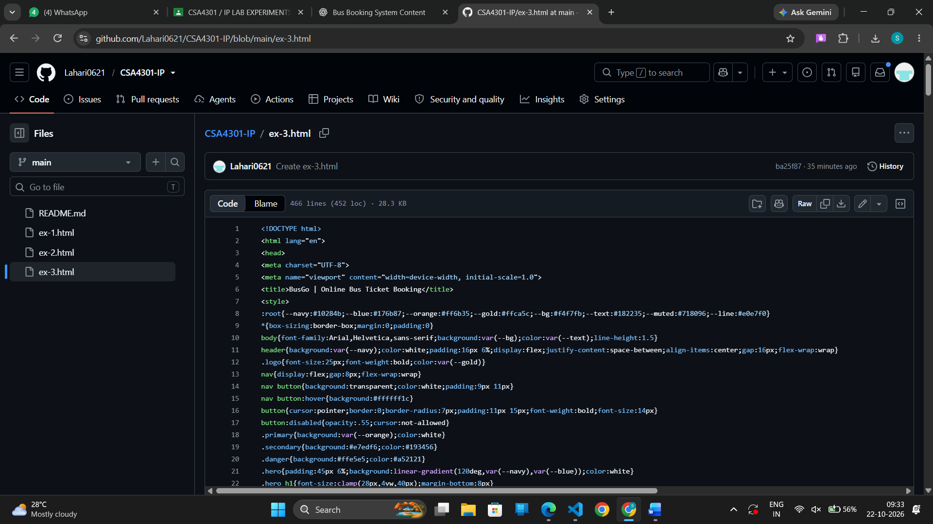
OUTPUT:
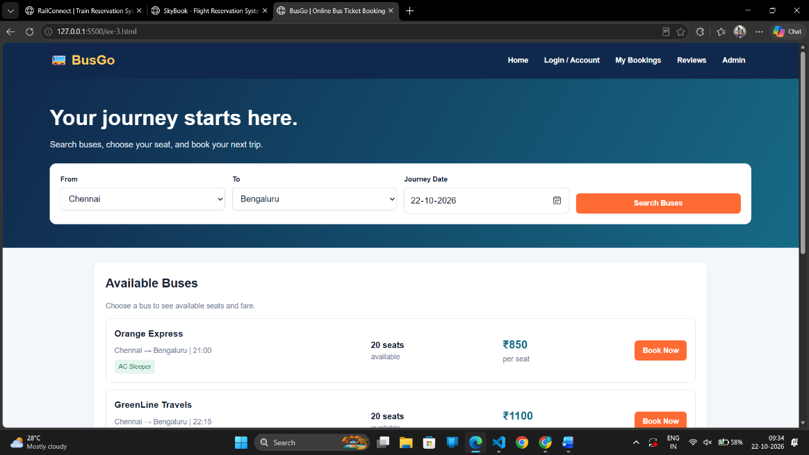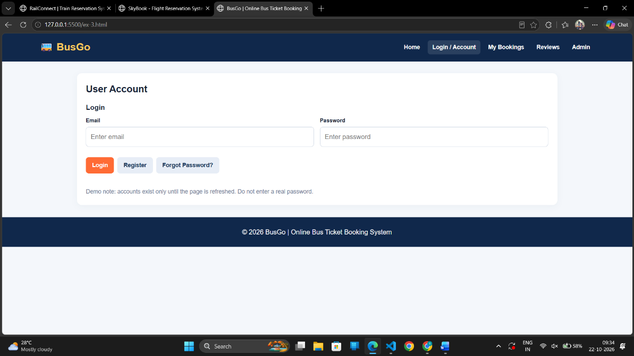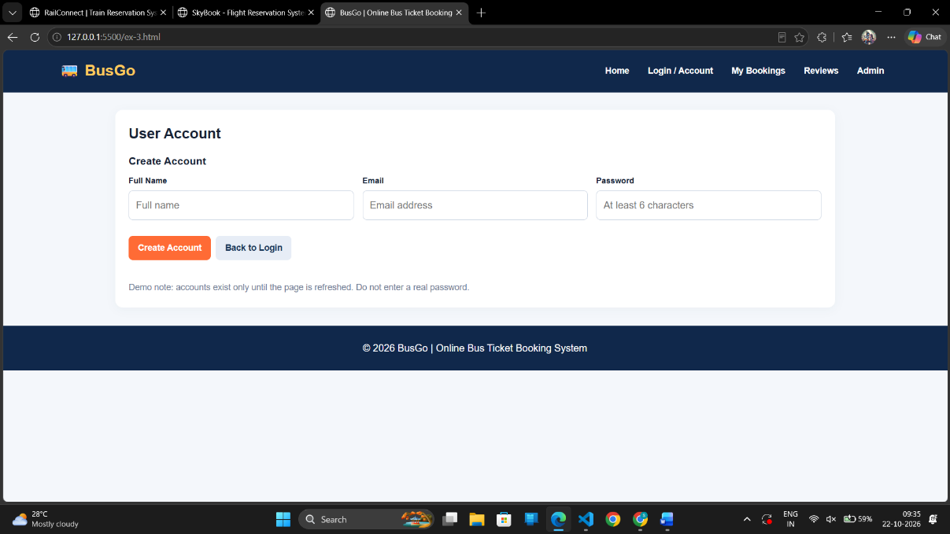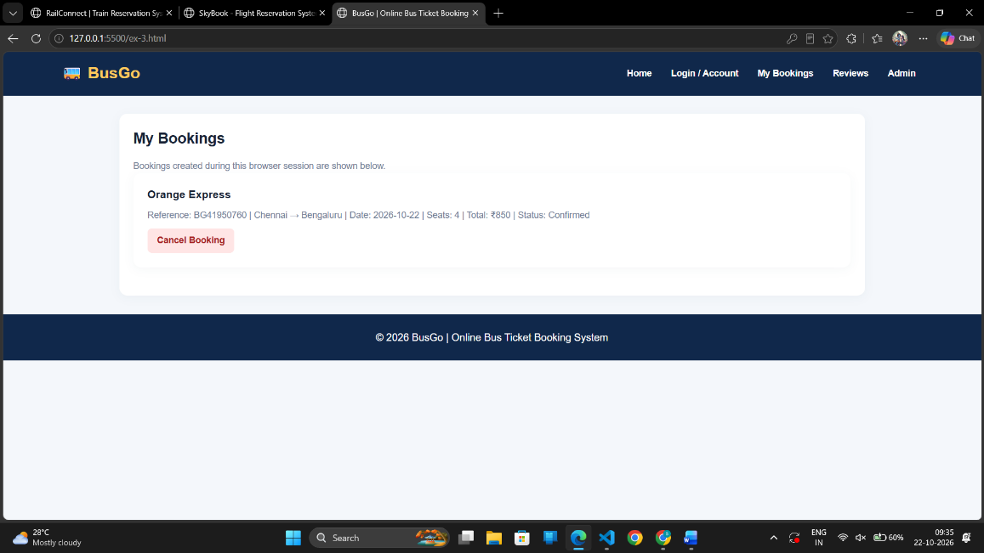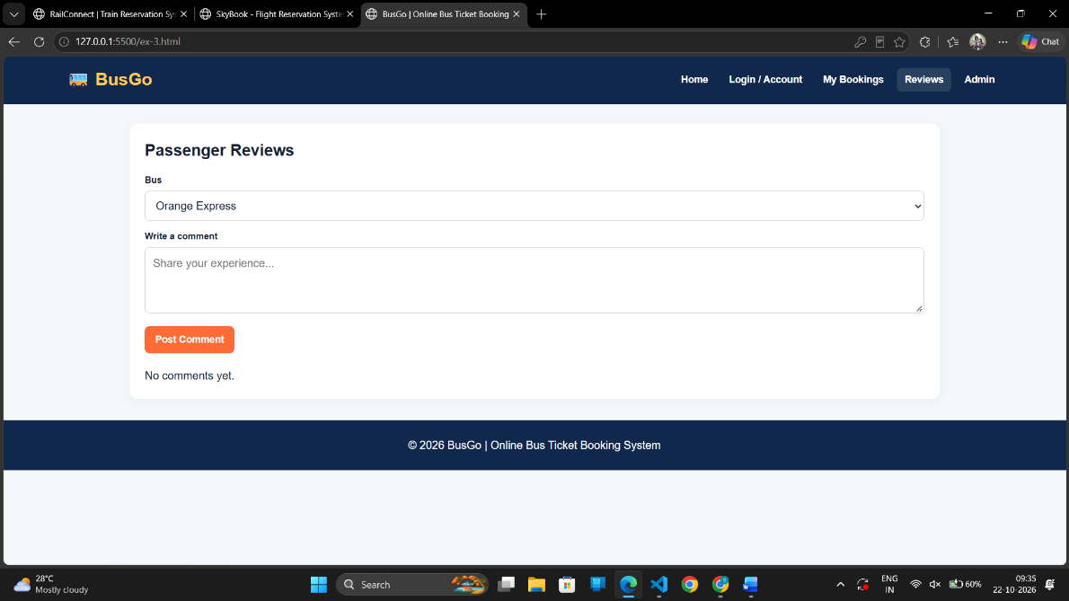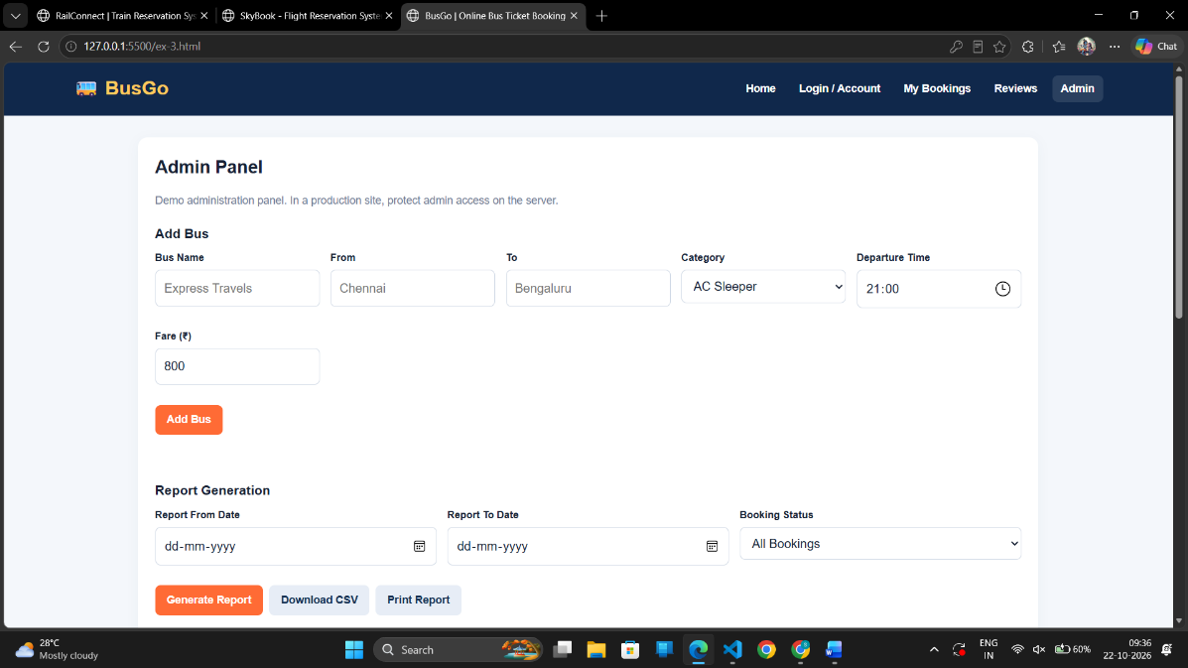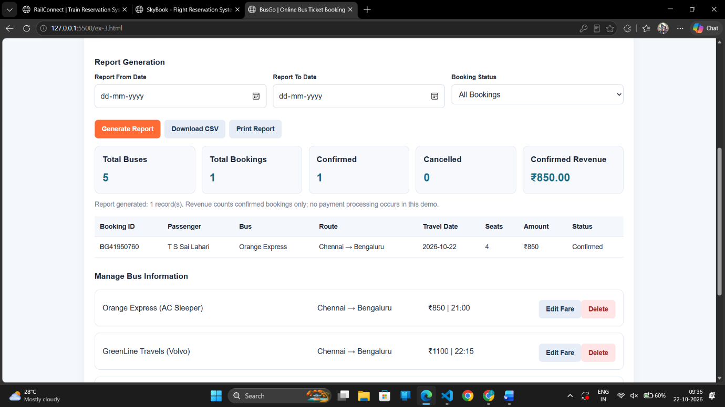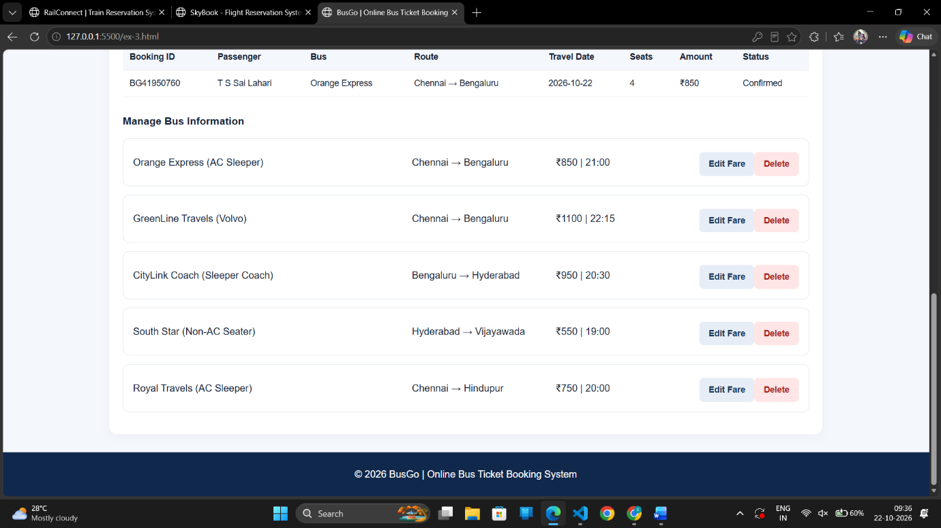

Result: Thus, the RailConnect Train Reservation System was developed successfully with train search, seat selection, ticket booking, PNR tracking, cancellation, and administration features.

4. The online train reservation system allows users to search for trains by route, date, and time, and view available seats and classes. Users can register, log in, and manage their reservations through a personal dashboard. The booking process involves selecting seats, entering passenger details, and making secure payments via an integrated payment gateway. Admins can manage train schedules, seat availability, and user accounts through a comprehensive admin panel. Users receive booking confirmation emails and can view their booking history and print tickets from their dashboard. The website features real-time seat availability updates and is fully responsive for seamless use on all devices.
The Reservation system should contain the following features:
1. If a passenger wants to reserve ticket(s), firstly, he/she has to log in to the Railway system with valid credentials. Then, the passenger has to provide his/her details with the date of the journey, names of the passengers and their details, origin station details, destination station details, and the class type of the required ticket(s).
2. The Railway Reservation System will provide the available Train-list, and Seat- availability, via-details.
3. To book a ticket passengers can pay through online/offline mode. After successful payment of the ticket fare the System will generate the ticket and PNR no. will be given to the passenger. The System also keeps the payment details and sends them to the system Admin.
4. The Passenger can check PNR status (confirmed, RAC, waiting list) by entering the PNR no. into the Reservation system.
5. The Reservation system should store all train details, fare details (by zone, class, and date wise), PNR no, date of trains, etc. This maintenance should be controlled by the Admin.
6. The System also has refund rules which have a date of reservation, ticket fare, and refundable percentage. The passenger can simply cancel the ticket(s) by entering the PNR no and a cancel ticket request. After cancellation, the admin will pass the refundable amount to the System and the System will give the refundable amount to the passenger.
Aim: To design and develop a responsive online train reservation system that allows users to search for trains, check seat availability, book tickets, make payments, generate PNR numbers, check reservation status, and cancel tickets with refunds. The system also enables administrators to manage train schedules, fares, seat availability, passenger details, and payment records.
CODE:
<!DOCTYPE html>
<html lang="en">
<head>
<meta charset="UTF-8">
<meta name="viewport" content="width=device-width, initial-scale=1.0">
<title>RailConnect | Train Reservation System</title>
<style>
:root {
--navy:#102a43;
--blue:#1769aa;
--blue2:#e8f3fc;
--gold:#f5b544;
--green:#16794b;
--red:#b42318;
--ink:#243447;
--muted:#64748b;
--line:#dce5ee;
--bg:#f4f7fb;
--white:#fff;
--shadow:0 12px 35px #102a4310;
}
*{box-sizing:border-box}
html{scroll-behavior:smooth}
body{margin:0;font-family:Arial,Helvetica,sans-serif;background:var(--bg);color:var(--ink)}
button,input,select,textarea{font:inherit}
button{cursor:pointer}
button:disabled{cursor:not-allowed;opacity:.55}
a{color:var(--blue)}

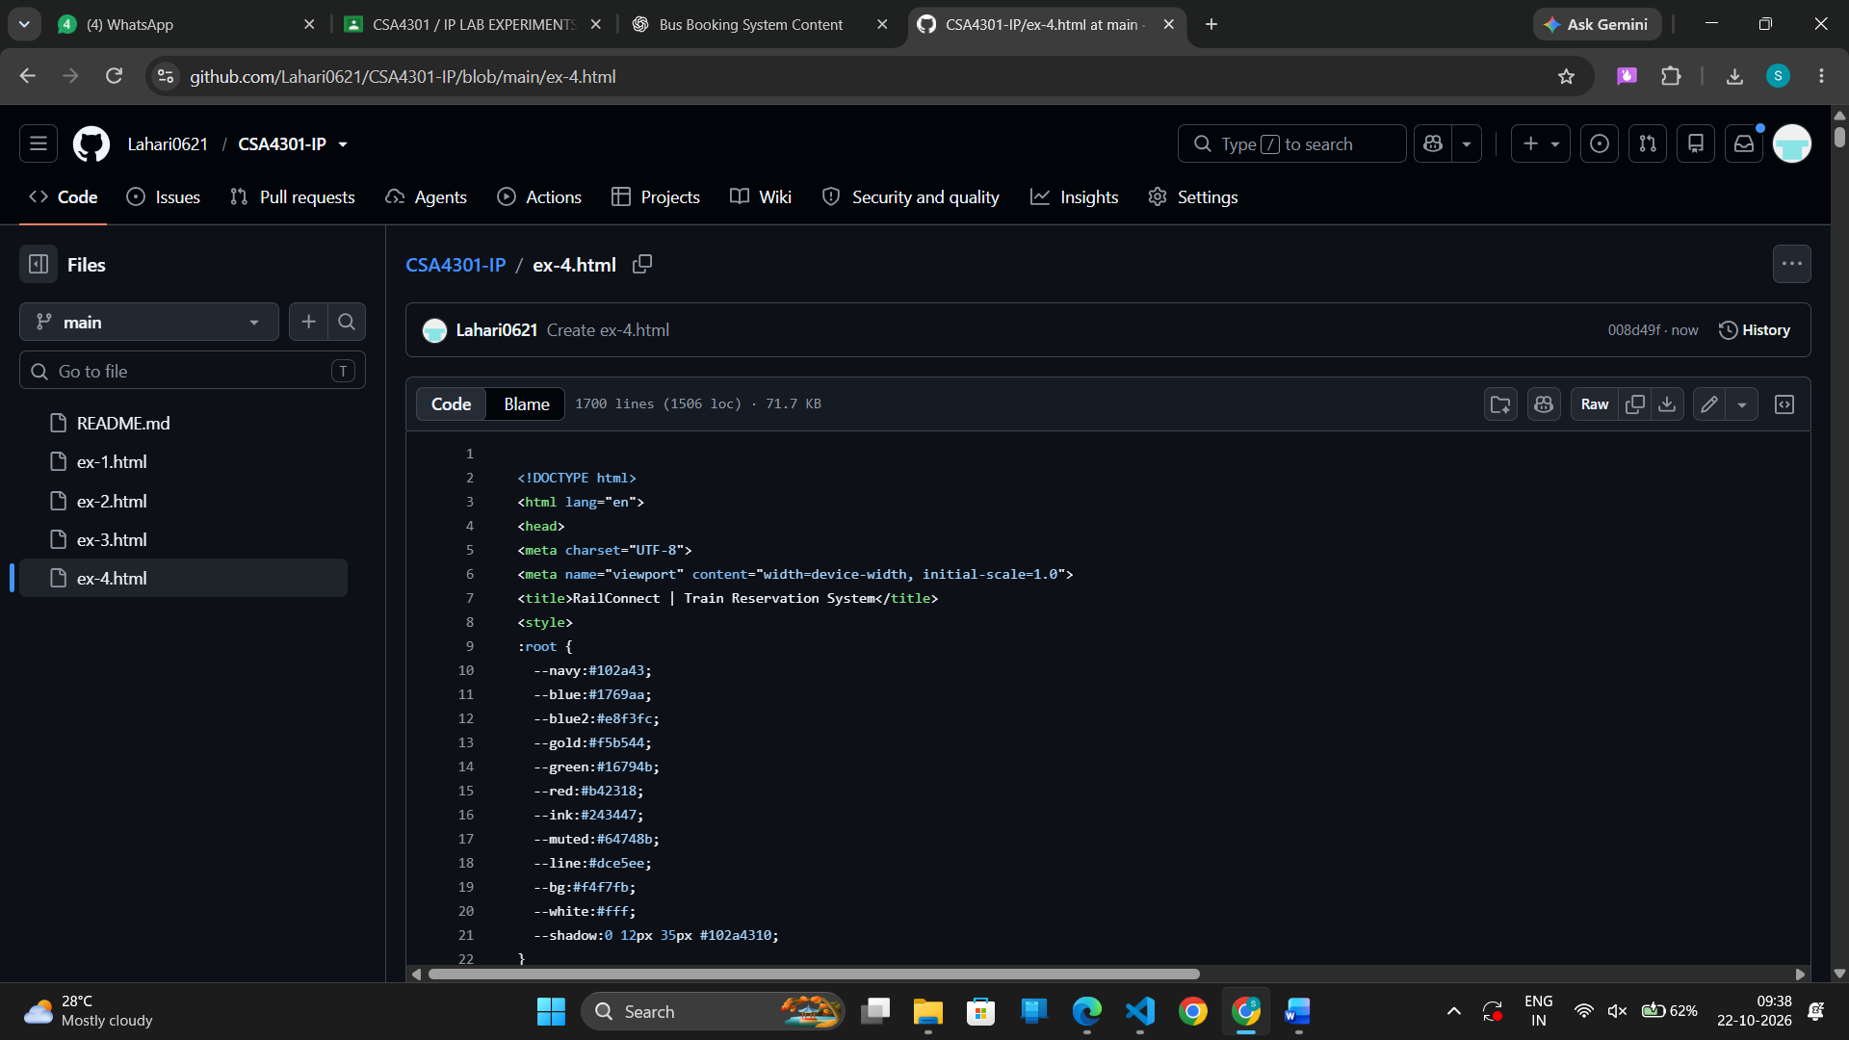
OUTPUT:
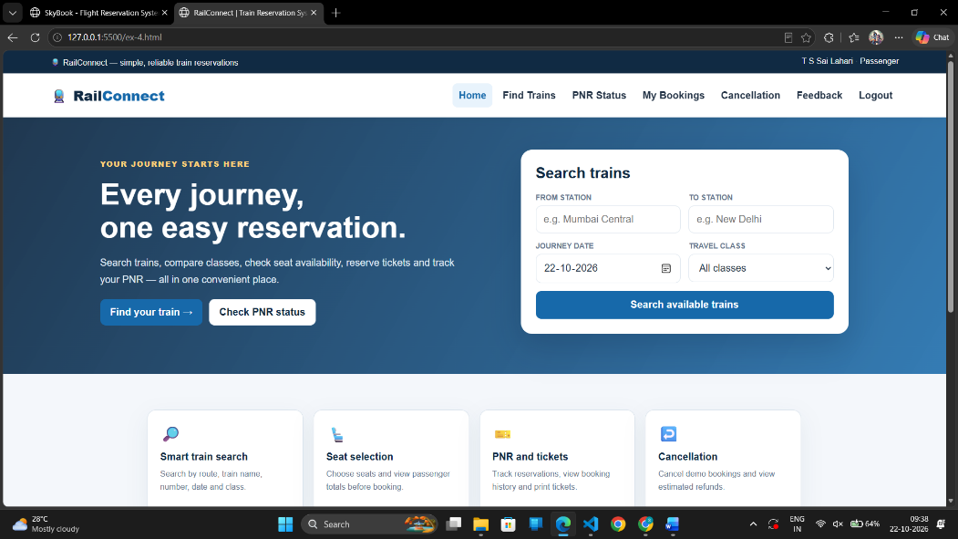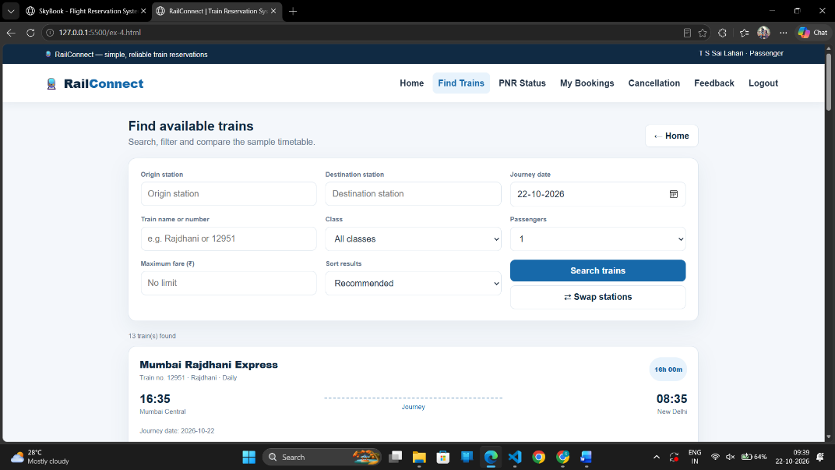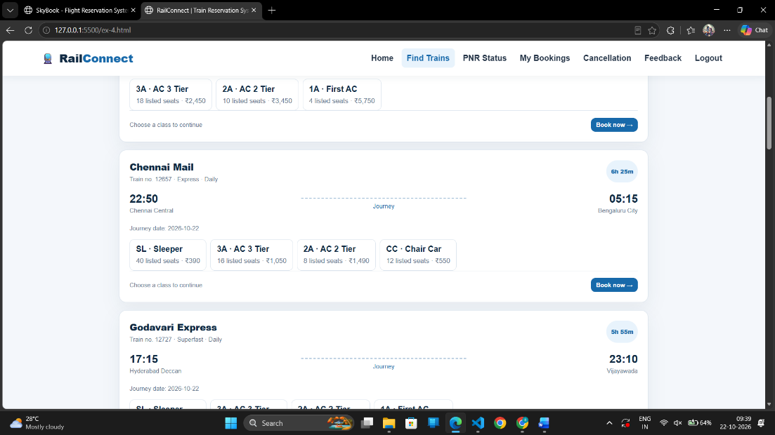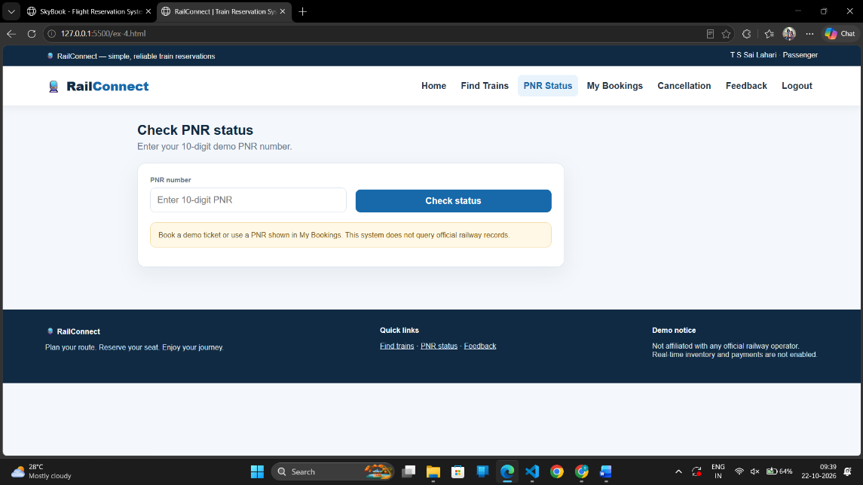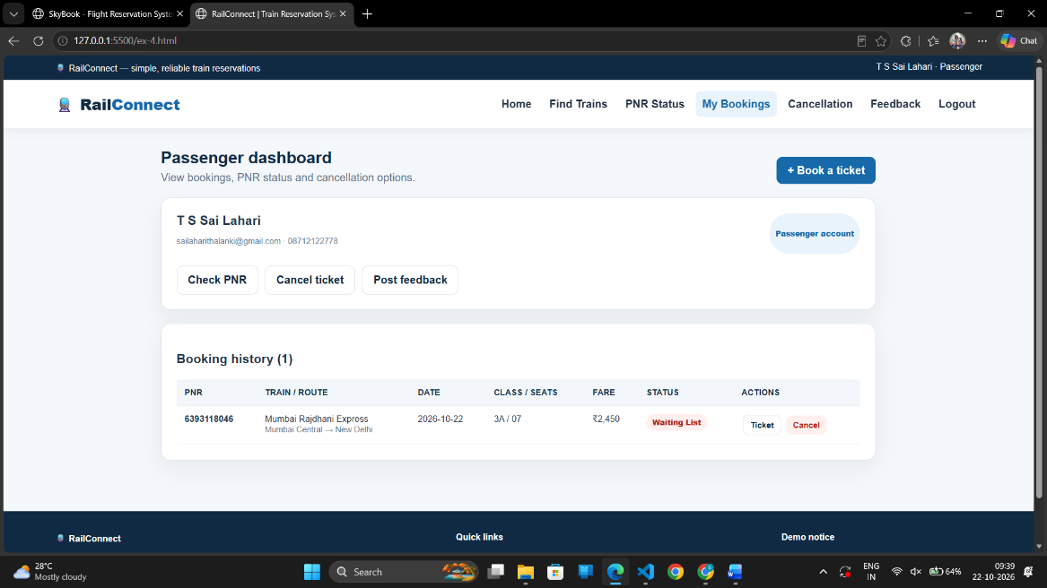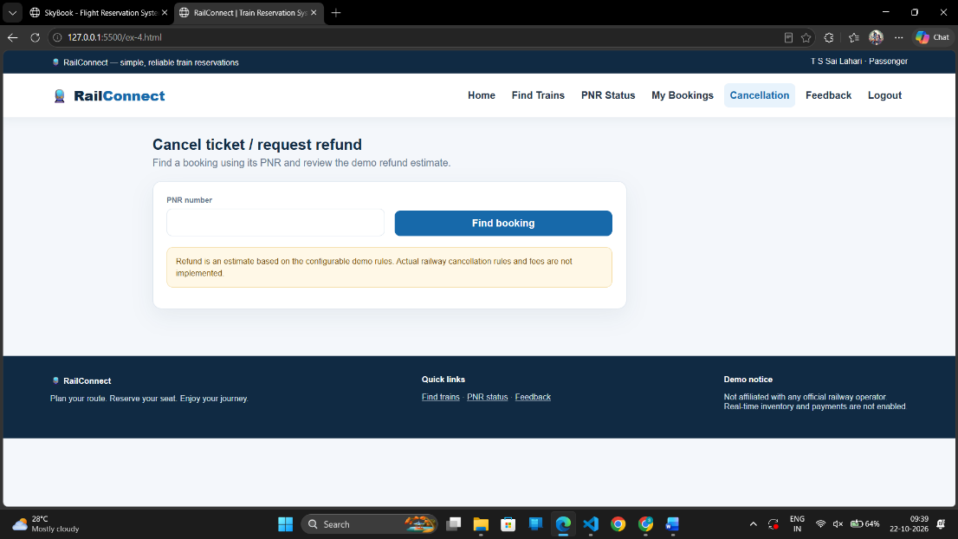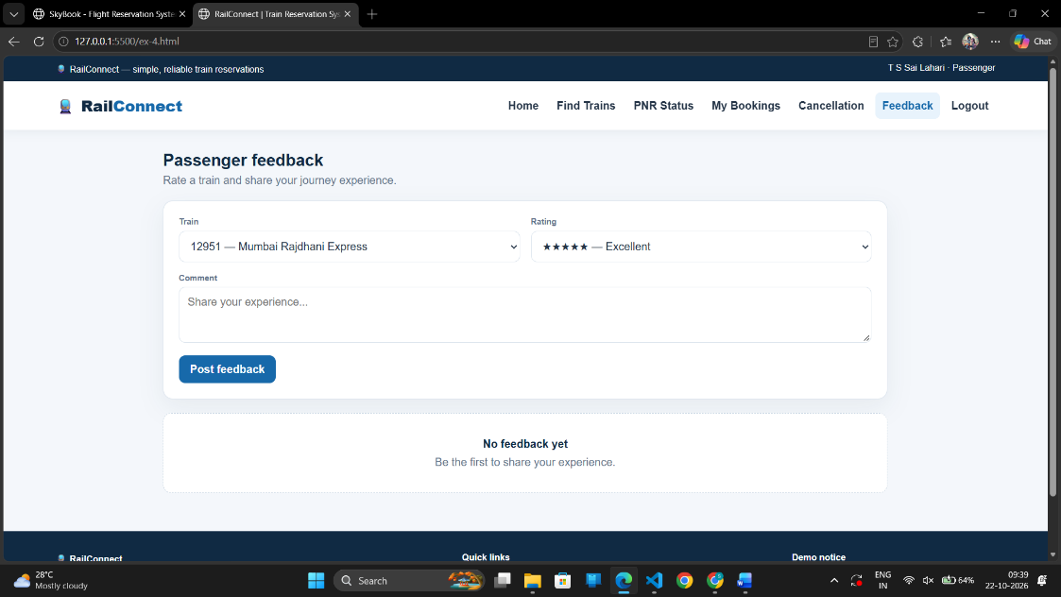

Result: Thus, the online train reservation system was successfully designed and developed with train search, seat availability checking, ticket booking, PNR generation and status checking, payment management, ticket cancellation, refund processing, and administrative management features.

5. The online flight reservation system enables users to search for flights by destination, date, and class, displaying available options with real-time seat availability. Users can register, log in, and manage their reservations via a personal dashboard. The booking process includes selecting flights, choosing seats, entering passenger details, and making secure payments through an integrated payment gateway. Admins can manage flight schedules, seat inventory, and user accounts using an advanced admin panel.
Users receive booking confirmation emails with e-tickets and can view their booking history and travel itineraries. The website is fully responsive, ensuring an optimal experience on all devices.The airline reservation system is a web-based system that helps in consolidating flight data - flight schedules, seat availability, flight fares and reservations from all airlines with the help of global distribution systems and provides real-time inventory and rates for customers and travel agents to book flight tickets online.
- Administrator User Login Page
- Forgot Password Page
- Search Flight Page
- Book Ticket Page
- Ticket Payment Page
- My Ticket Page
- Cancel Ticket Page
- Customer Feedback
- Admin Report • Search Flight Page
- View Booking Status Page
- Print Ticket Page
Aim: To design and develop a responsive Flight Reservation System named SkyBook using HTML, CSS, and JavaScript that allows users to search flights, book tickets, select seats, make demo payments, view and print e-tickets, check booking status, cancel tickets, submit feedback, and manage flight reservations through an administrator dashboard.
CODE:
<!DOCTYPE html>
<html lang="en">
<head>
<meta charset="UTF-8">
<meta name="viewport" content="width=device-width, initial-scale=1.0">
<title>SkyBook | Flight Reservation System</title>

<style>
:root {
--navy: #102a43;
--blue: #1769ff;
--blue-dark: #1054d4;
--light: #edf5ff;
--bg: #f5f8fc;
--white: #ffffff;
--text: #24364b;
--muted: #738198;
--border: #e2eaf4;
--green: #12805c;
--red: #d94848;
--shadow: 0 12px 35px rgba(25, 61, 105, .08);
}
* {
box-sizing: border-box;
}
html {
scroll-behavior: smooth;
}
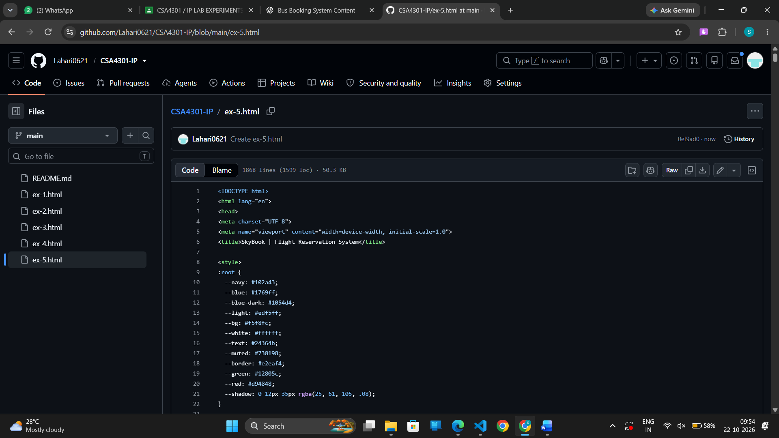
OUTPUT:
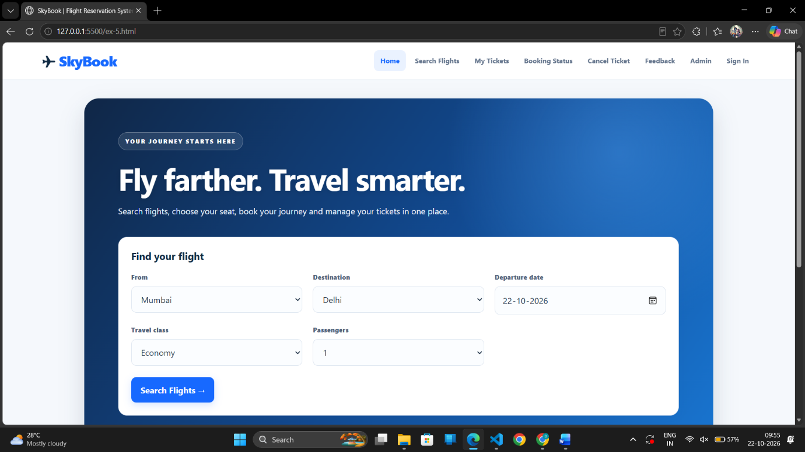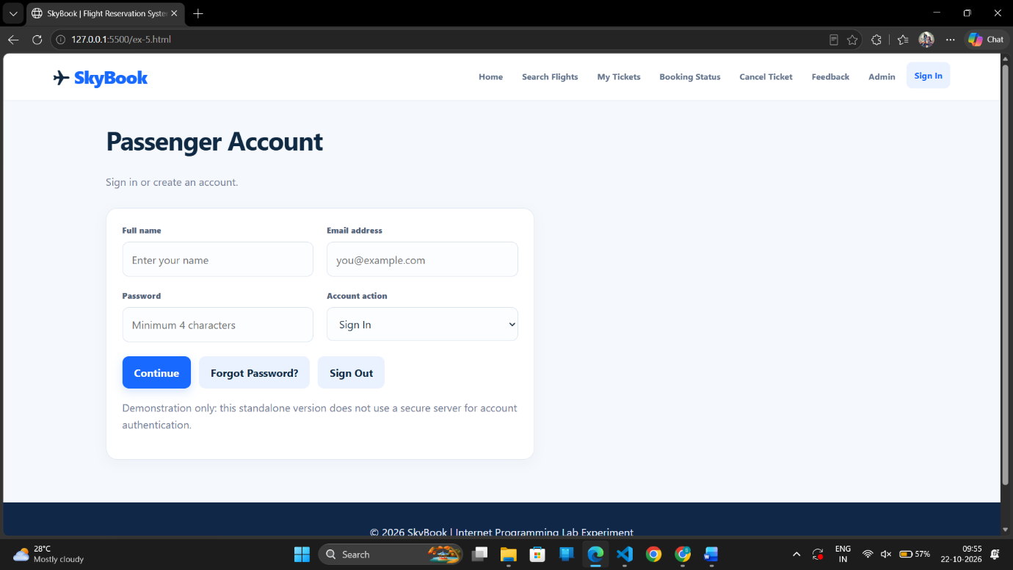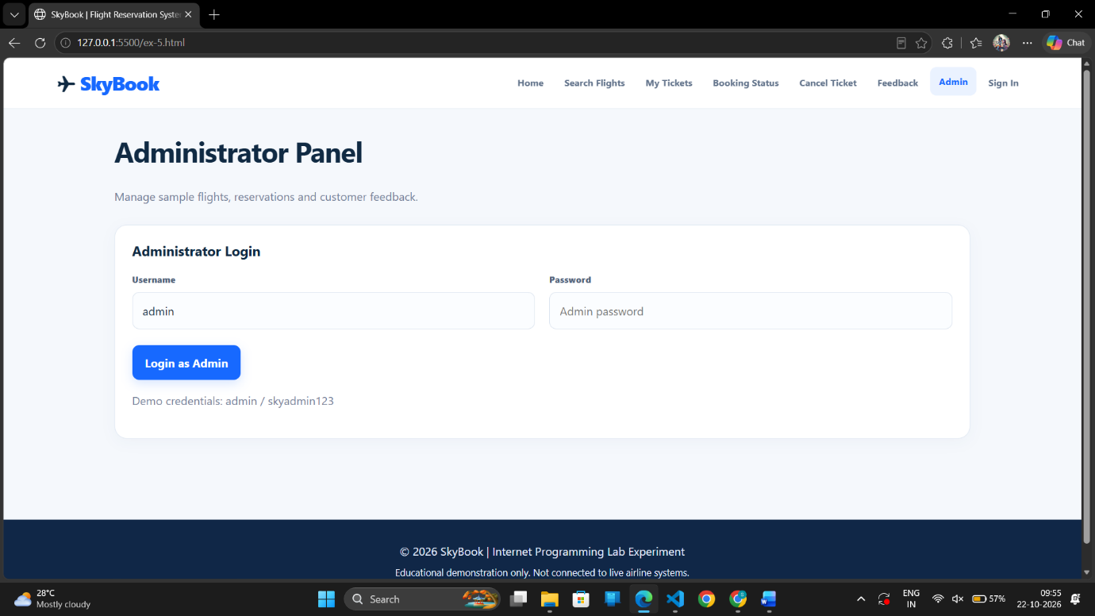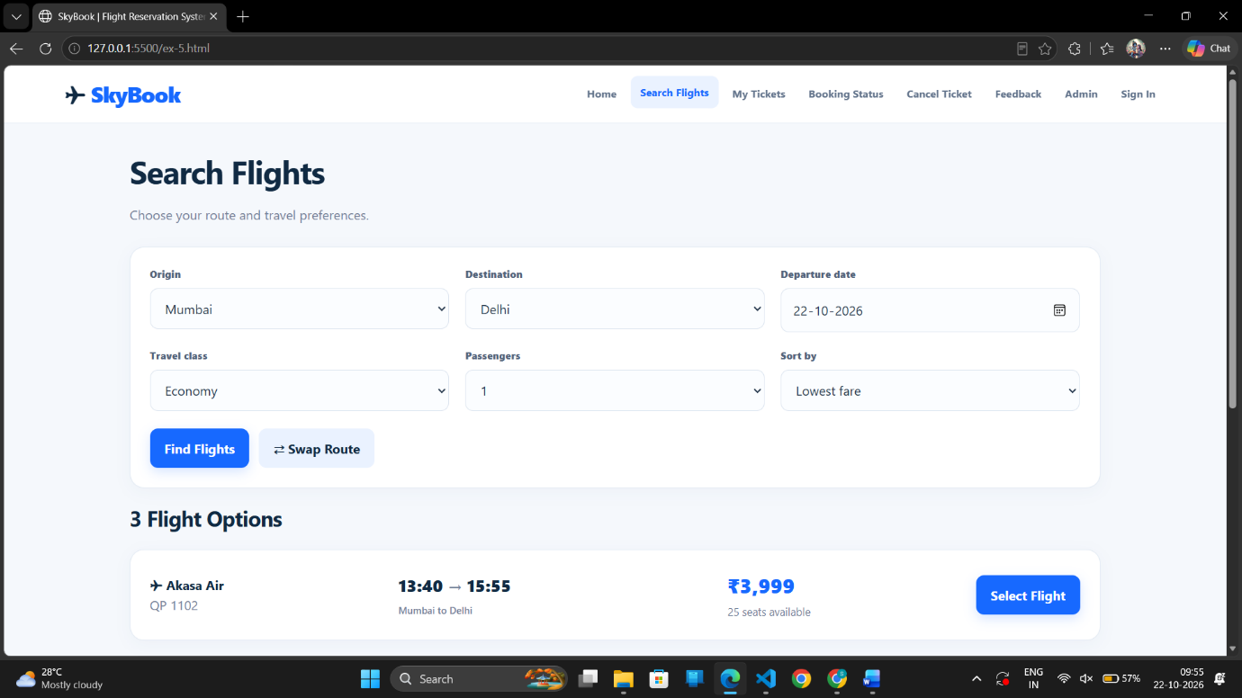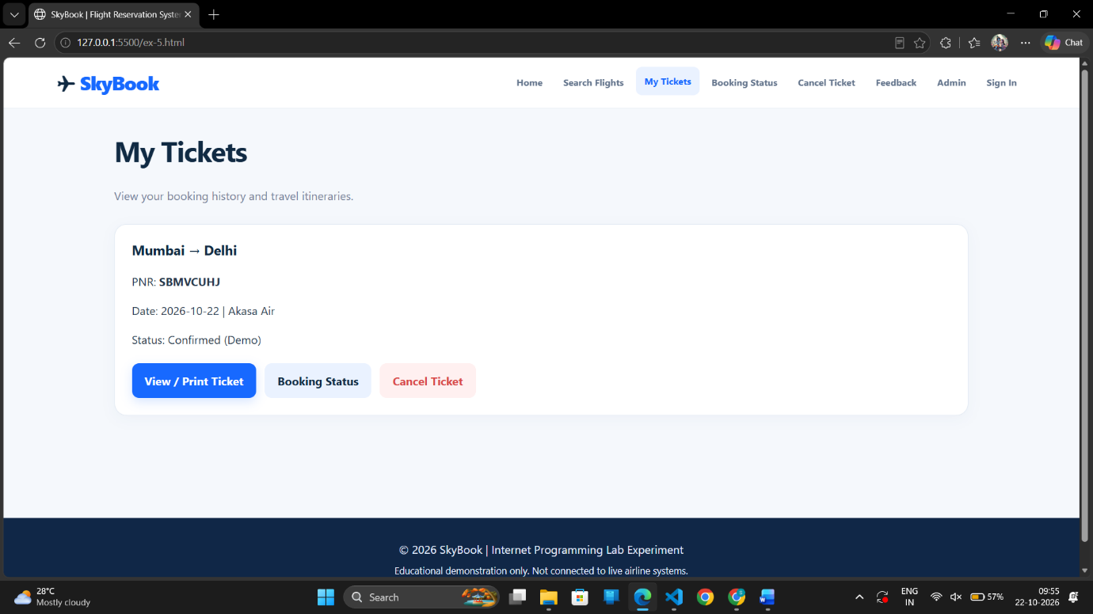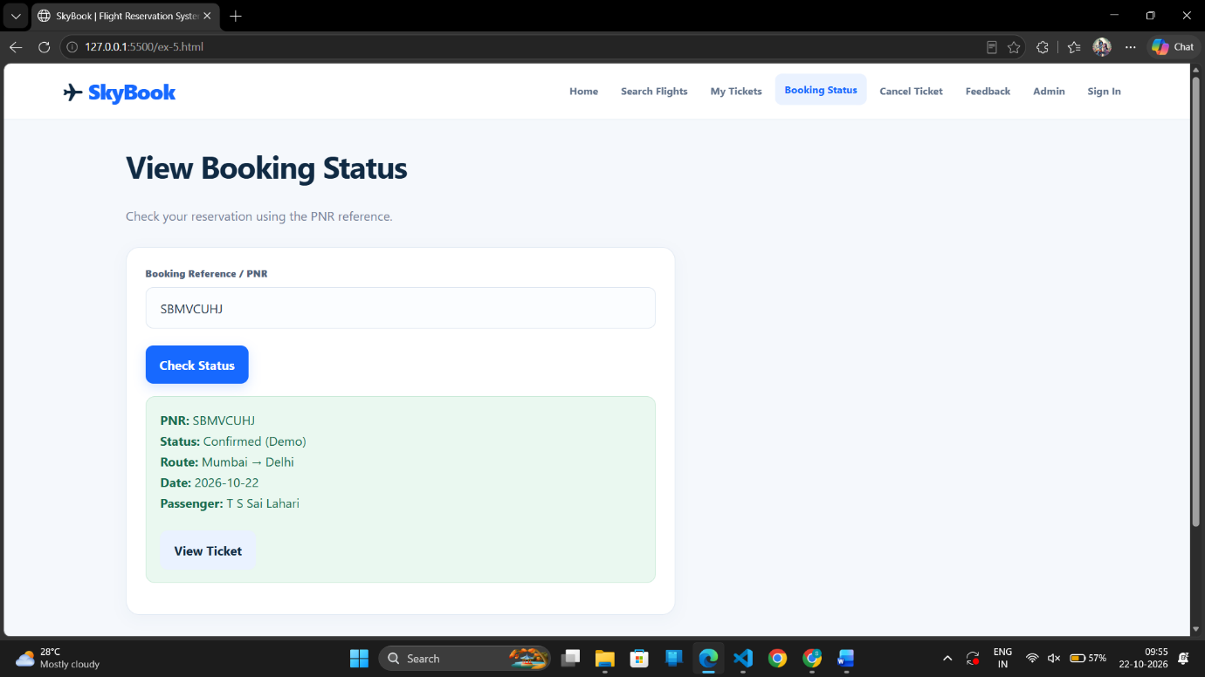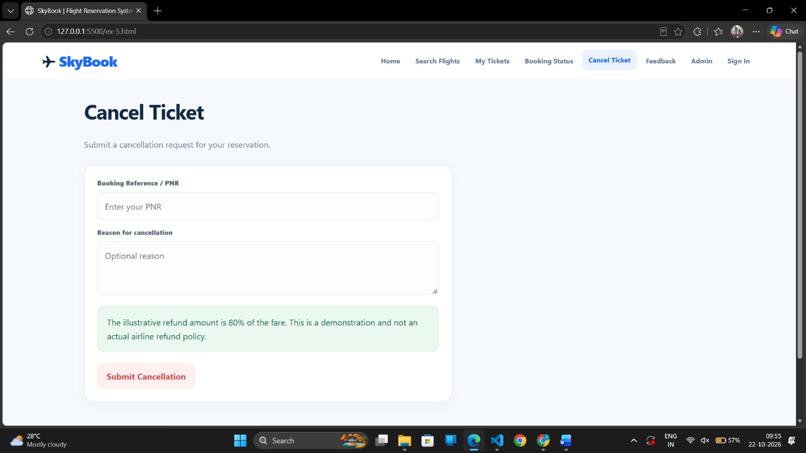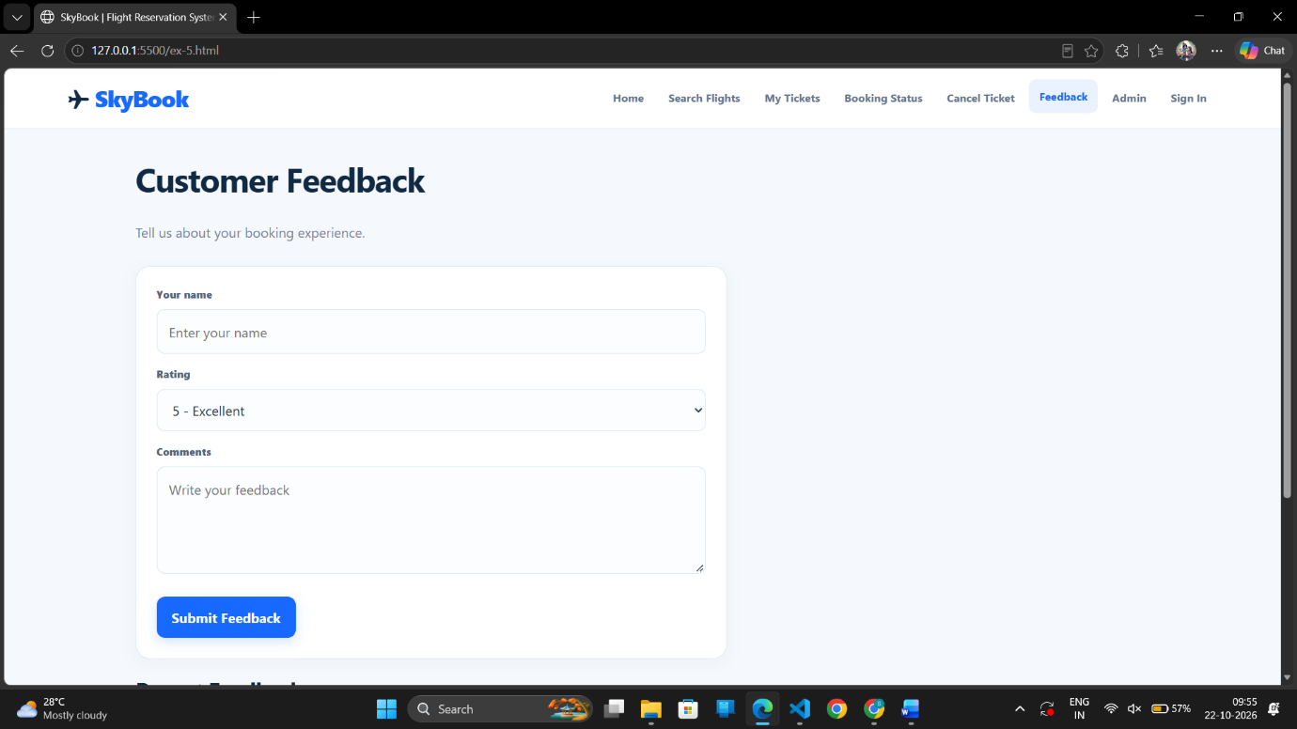

Result: The SkyBook Flight Reservation System was successfully designed and developed with a user-friendly, responsive interface. The system supports flight searching, ticket booking, seat selection, simulated payment confirmation, e-ticket generation and printing, booking status verification, cancellation requests, customer feedback, and administrative reports using browser local storage.

6. The online cake ordering system allows users to browse a variety of cakes by category, flavor, and occasion, complete with detailed descriptions and images. Users can register, log in, and manage their orders through a personal dashboard. The ordering process includes selecting a cake, customizing options like size and message, entering delivery details, and making secure payments via an integrated payment gateway. Admins can manage cake inventory, track orders, and handle user accounts through an admin panel. Users receive order confirmation emails and can track delivery status. The website is fully responsive, providing a seamless shopping experience on all devices. Buy a Cake is a portal which allows admin in developing counters to advertise and sell their cake. This would permit rural communities to make their wares available to the rest of the world. The proposed system is to develop the website for cake store. User can buy the nearby cake available in app. An E Com App is a portal which allows admin in developing products to promote and sell their goods. This would permit rural communities to make their wares available to the rest of the world.
Admin
- Login
- Manage Products
- Post Cake details
- Upload images
- Product • Description
- Manage Orders
- Update order Status
- Shipping Location
- Logout
Student
- Register
- Login
- Search Cake
- Filter
- Category
- Sub category
- Price Range
- View Cake list • View cake description
- Add to Cart • Place order
- Add Shipping Address
- Update Shipping Address
- My Order
- View Shipping Status

Aim
To design and develop a responsive Online Cake Ordering System using HTML, CSS, and JavaScript that allows users to register, log in, browse and search cakes, filter cakes by category and price, customize cake orders, add cakes to a cart, enter shipping details, place orders, and track delivery status. The system also provides an admin panel to manage cake products, upload images, manage inventory, and update order statuses.
CODE:
<!DOCTYPE html>
<html lang="en">
<head>
<meta charset="UTF-8">
<meta name="viewport" content="width=device-width, initial-scale=1.0">
<title>SweetSlice | Online Cake Ordering</title>

<style>
* {
margin: 0;
padding: 0;
box-sizing: border-box;
}

:root {
--pink: #e85d8e;
--dark: #3b2430;
--light: #fff5f8;
--muted: #777;
--white: #fff;
}

body {
font-family: Arial, sans-serif;
background: #fffafb;
color: var(--dark);
}

button, input, select, textarea {
font: inherit;
}

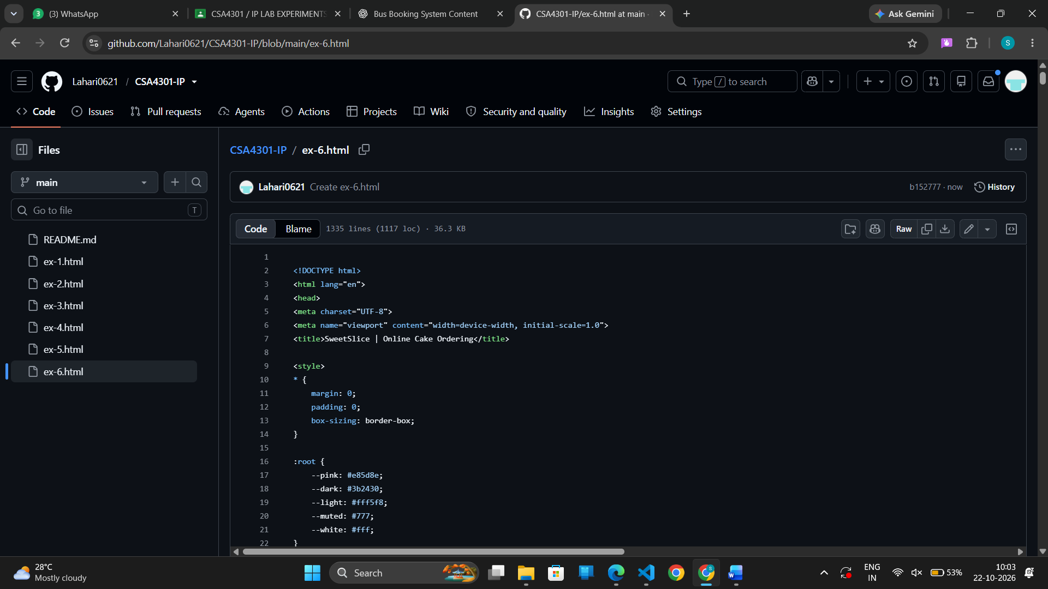
OUTPUT:
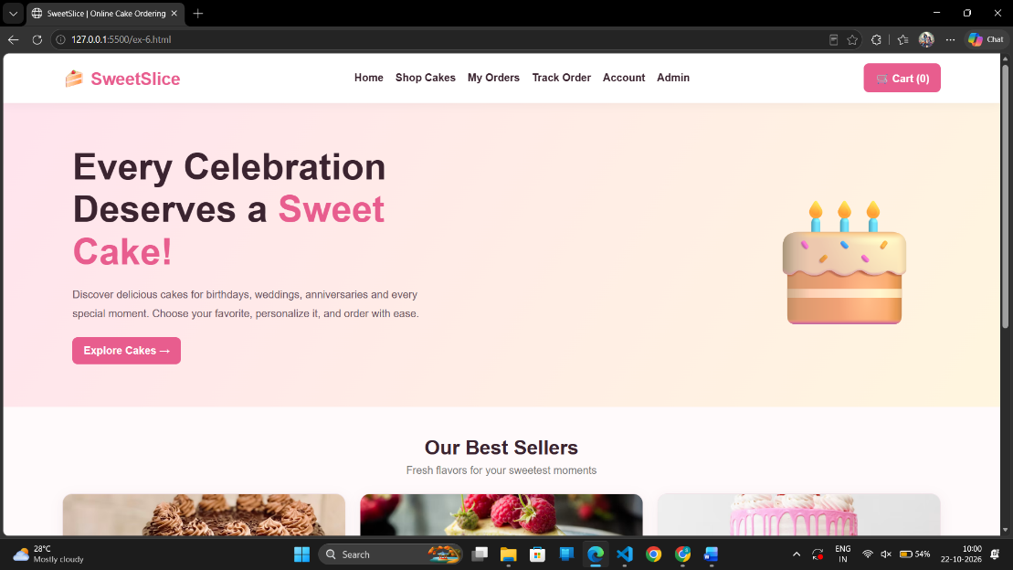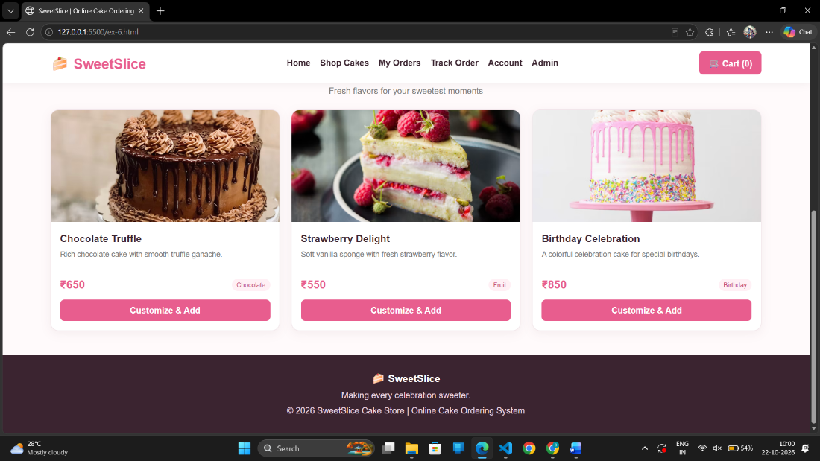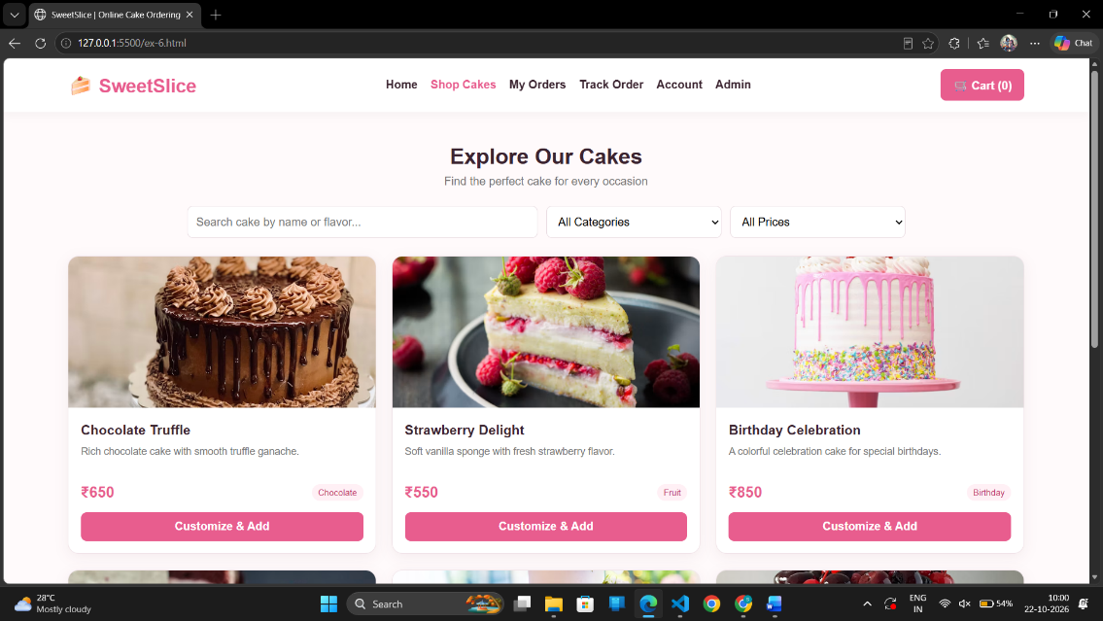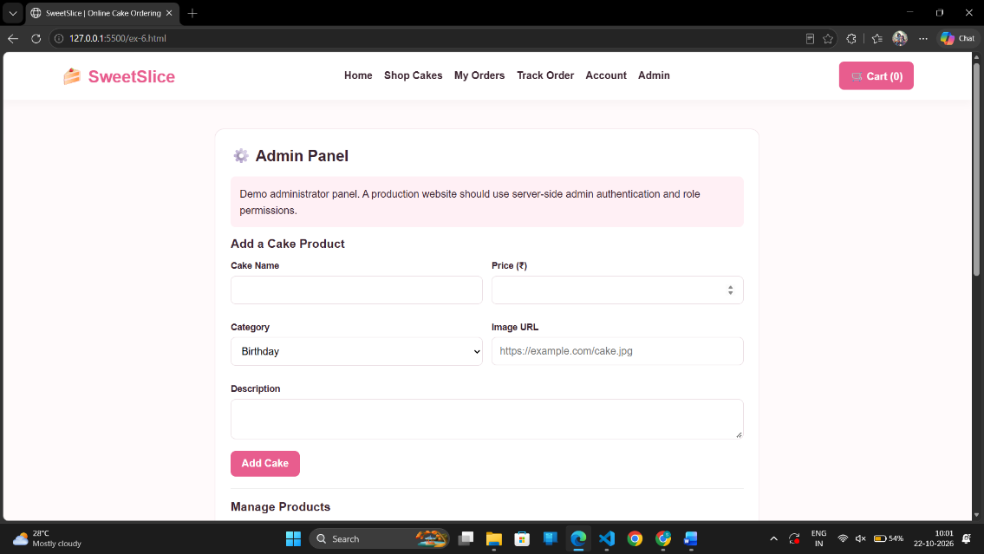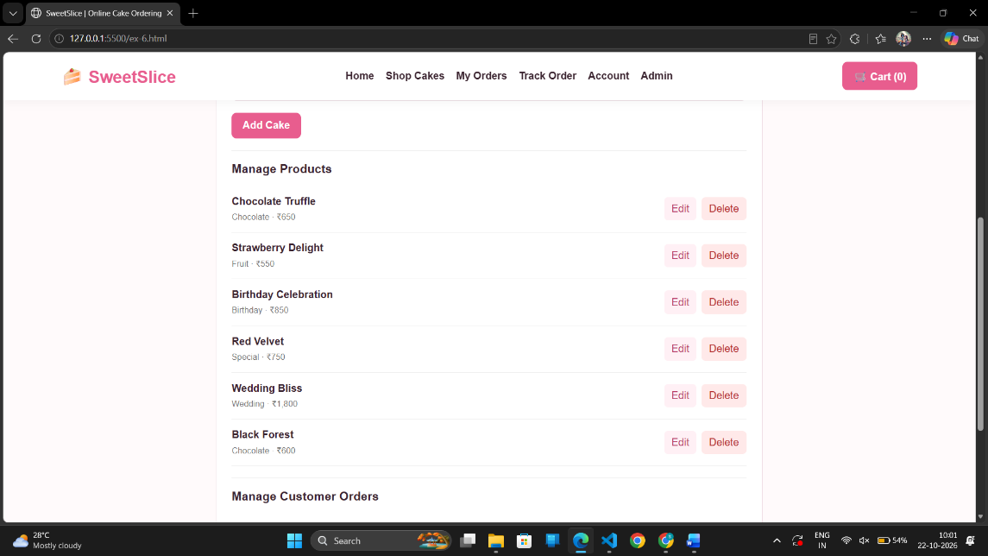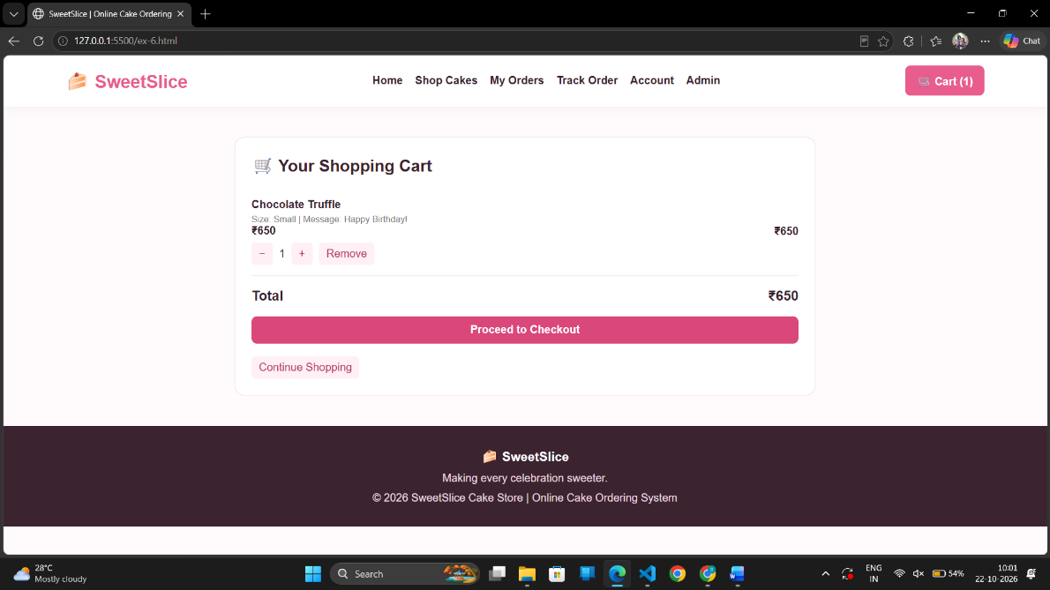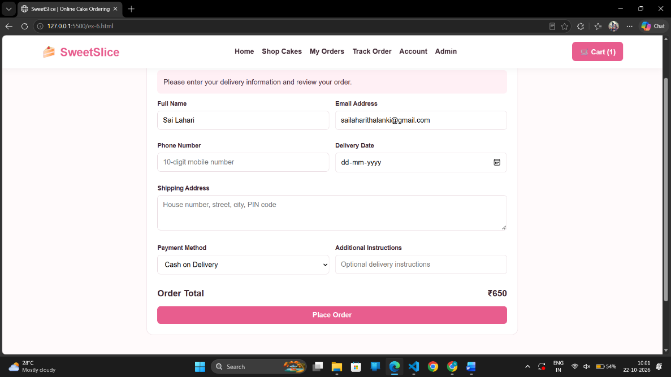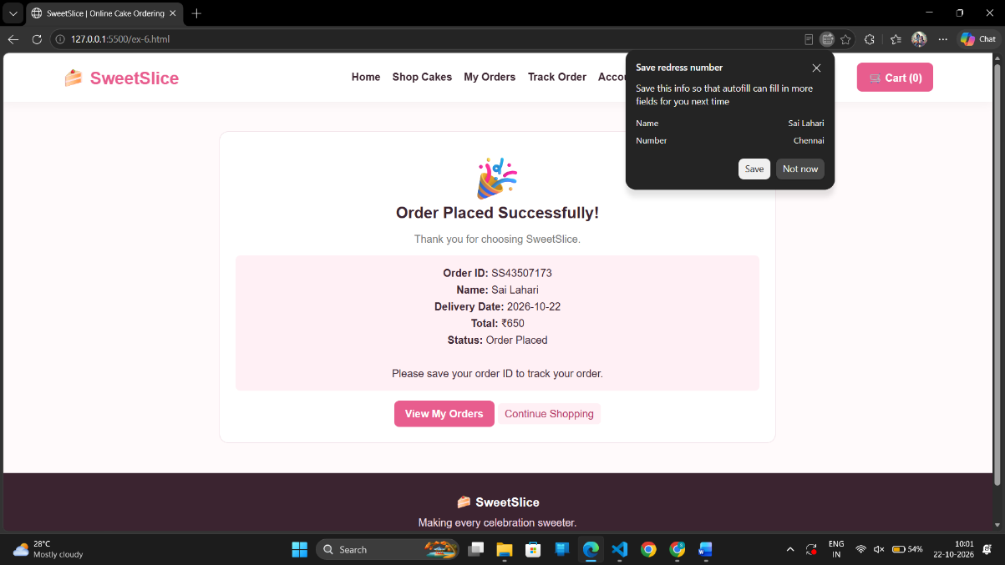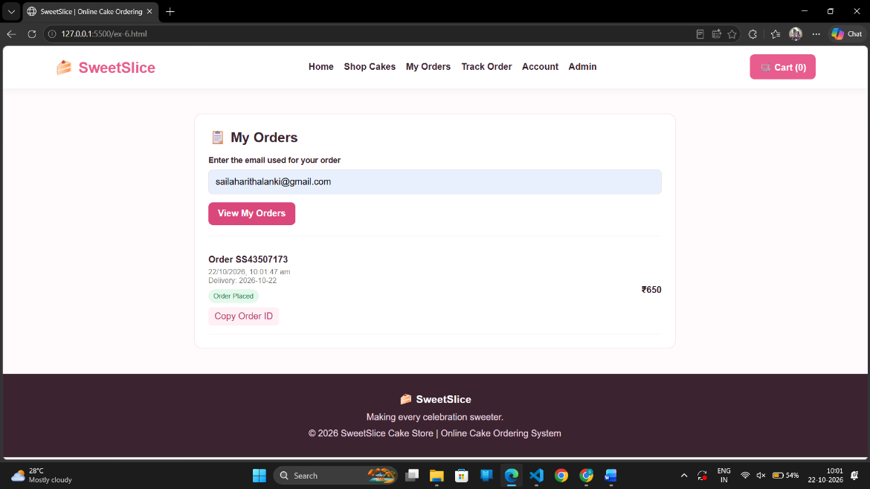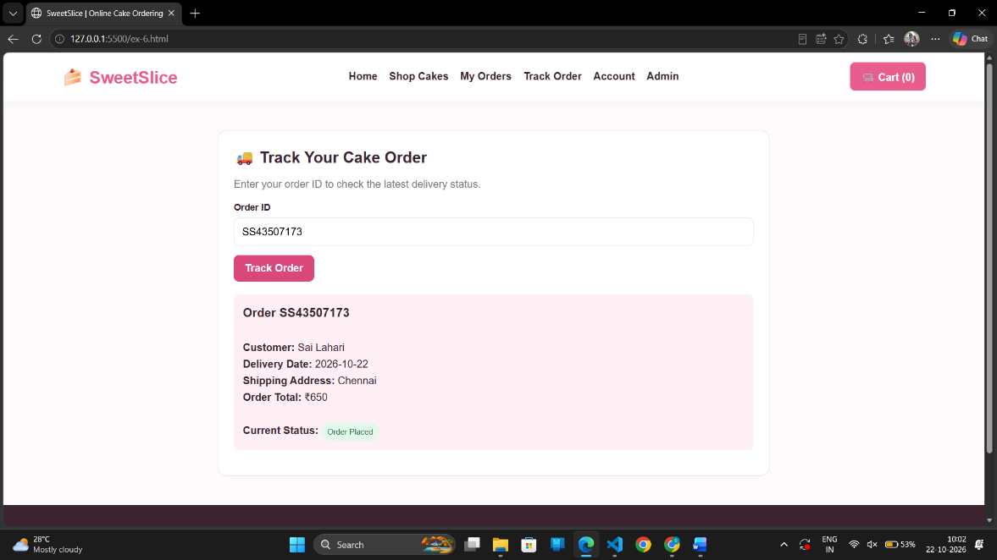
Result
The Online Cake Ordering System was successfully designed and developed with a user-friendly, responsive interface. It supports cake browsing, category-based filtering, product descriptions, cart management, order placement, shipping address management, order tracking, and administrative product and order management.

